_________________

_________________
_________________
_________________

Dear Sir/ Madame:

Compliments of Peace!

The Regional Federation of Junior Philippine Institute of Accountants - Region X and Caraga Council (RFJPIA - X and Caraga) is the umbrella organization and a family of all Accountancy students in the joint-region. As a partner of the National Federation of Junior Philippine Institute of Accountants (NFJPIA), RFJPIA aims to realize a home of solidarity, a training ground of leadership skills and a showground of academic and non-academic potentials to more than 3000 future professionals.

In pursuit of honing students’ excellence, we would like to invite your good school to our most highlight activity for this academic semester, the 21st Annual Regional Convention with the theme, “Embracing Fecundity. Continuing Excellence” which will be hosted by Father Saturnino Urios University at Butuan City on January 26-28, 2013. Furthermore, attending delegates in this convention would be representatives from different local chapters, advisers, school deans, and faculties and guests from auditing firms.

The stay-in conference intends to impart to the delegates the concepts of leadership, character building and sense of national pride and vision. It will also introduce them to the concepts, practices and operational tools of group dynamics for their self-improvement and preparation as future professionals and leaders of the country.

The highlight of the 21st Annual Regional Convention would include among others the following:

Academic Events
- Academic Conference
- RFJPIA Cup Series
- President’s Cup
- Word Wizard: Battle of the Lexicon Giants

Non Academic Events
- 3rd Cine JPIA
- X Factor Region 10 and CARAGA -Duo
- Dance Craze 2013
- JPIANS Got Talent Season 3
- The Amazing Race 2013
- Mixed Volleyball
- Men’s Basketball
- RFJPIA’s Next Top Models

For more information, you may communicate with our Communication Officer:

ANTHONY BODBOD
0935 143 3635
vpcomm.nfjpiaxcaraga@gmail.com

We look forward to enjoy the celebration with you. Thank you so much and God bless us all!

Sincerely yours,
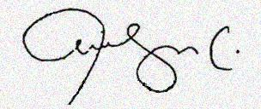

ROSAMUND FAYE MELIG
Chairperson, 21st Annual Regional Convention
Regional President

Noted:
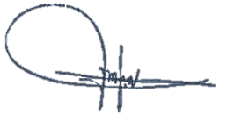

ATTY. JENNY G. UPLINGER, CPA
Regional Adviser

