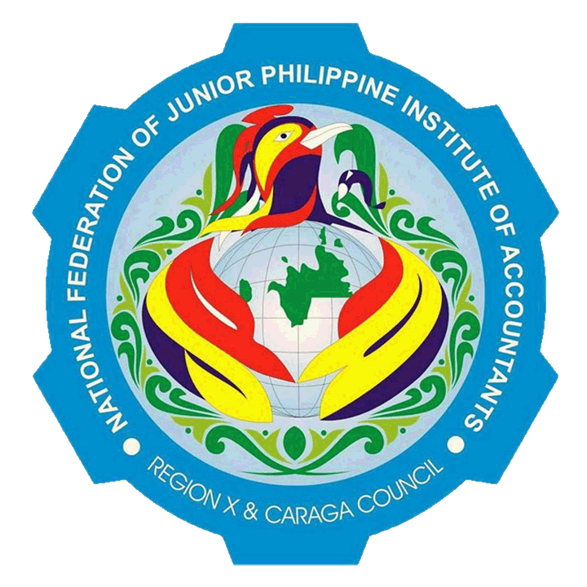
21st Annual Regional Convention

“Embracing Fecundity. Continuing Excellence”
Father Saturnino Urios University, Butuan City
January 26-28, 2013

Itinerary of Events

DATE/TIME | ACTIVITY | VENUE | DRESS CODE
January 26, 2013
8:00am -12:00noon | Estimated time of Arrival of Delegates  Registration | CB Lobby  Waiting Area: Kiosk | Local Chapter T-shirt
12:00 noon | Check-In | Hotels
 | Academic Events |  | Collared T-shirt
1:00pm-3:00pm | Word Wizard | Morelos  Classroom
3:00pm-5:00pm | Most Outstanding JPIAn 2013  - Essay Writing Competition | Morelos  Classroom
 | President’s Cup | Morelos Classrooms
 | Non-Academic Event | Morelos Gym | Local Chapter T-shirt
1:30pm-5:00pm | The Amazing Race 2013
 | Men’s Basketball | Morelos Gym | Sportswear
6:00pm-7:00pm | Dinner | Morelos Gymnasium
7:15pm-11:00pm | Opening Ceremonies
 | Non-Academic Events | Morelos  Gymnasium | Vampire-Inspired
 | X Factor
 | Dance craze
 | RNTM
January 27, 2013
6:00am-7:00am | Breakfast | Hotel
 | Academic Events |  | Corporate
7:00-9:00am | RFJPIA Cup 1 | Tangelder Library
 | RFJPIA Cup 2  RFJPIA Cup 3 | Jansen Library  AVR 3
9:00-11:00am | RFJPIA Cup Series Level 2 | Haggenburg
 | Non-Academic Events
7:00-11:00am | Mixed Volleyball | CBS Grounds | Sports wear
 | Men’s Basketball | CB Basketball Court
 | 3rd Cine JPIA Film Showing | AVR 1 | Casual
11:30-12:45pm | Lunch | CB Lobby
 | Academic Events |  | Corporate
1:00-4:00pm | Academic Conference  - Sir Jekell G. Salosagcol, CPA | Haggenburg
4:00-6:00 pm | Most Outstanding JPIAn 2013  - Extemporaneous Speaking Competition | AVR 2
 | Non-Academic Events
1:00-4:00pm
 | 3rd Cine JPIA Film Showing | AVR 1 | Casual
6:30-7:30pm | Dinner | FSUU Gym
7:30-12:00am | Awarding Ceremonies/
 | Non-Academic Events | FSUU Gym | Formal Wear (Black & White)
 | X Factor
 | Got Talent
 | RNTM
January 28, 2013
6:00am-7:00am | Breakfast | Hotel
9:00am-11:00am | Election for New Set of Officers | AVR 2 | Corporate
11:00am | Departure

